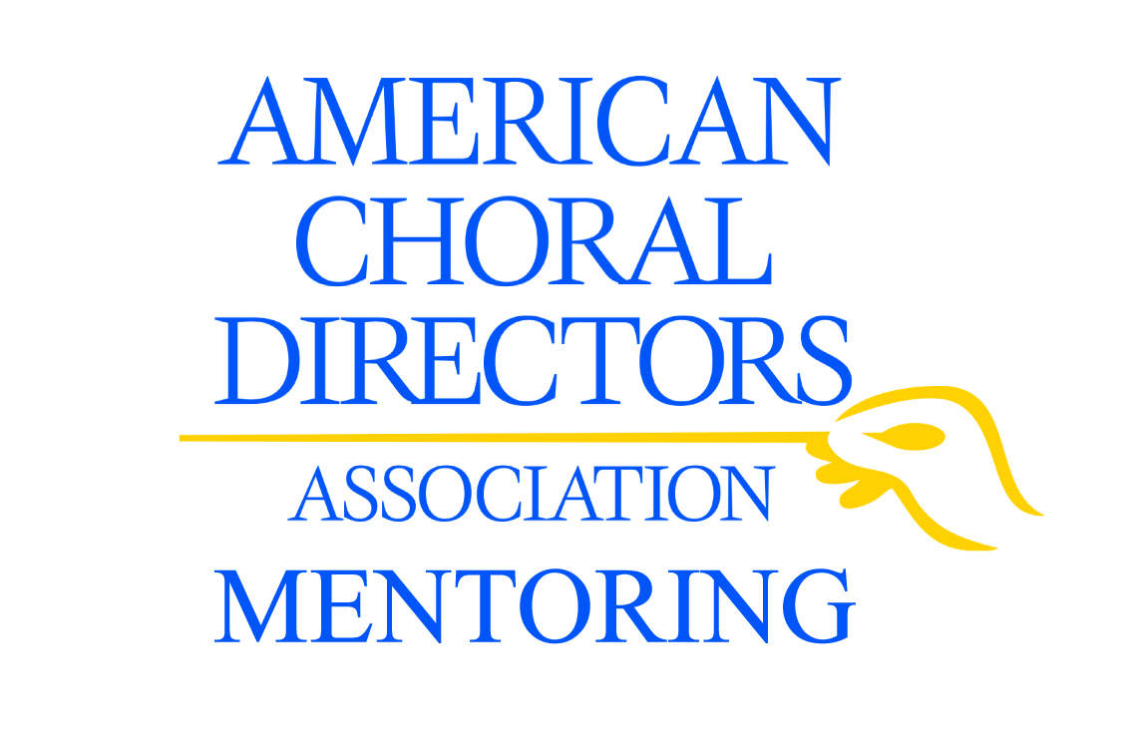

The American Choral Directors Association is focusing on mentoring as a way to assist our membership in encouraging lifelong professional growth and identifying resources and allies.

Who Can Participate?
The American Choral Directors Association (ACDA) Mentoring Program is open to ACDA members across the country. The program is available to all students, choral teachers, and choral conductors, whether employed or still searching for a position. Mentors and mentees (or protégés) must be ACDA members (Active, Student, Retired, or Life categories all qualify).

To Get Started
Mentees register online, are approved (once we verify their membership), review the ACDA Mentoring Guide to understand what the program is, and then fill out an online profile. Mentees must re-enroll in each new mentoring session they would like to participate in.

Mentors register, and then complete an online profile to become part of the searchable pool of mentors. Once mentors register, they stay in the program indefinitely – they can take themselves in and out of the searchable pool as they wish, and identify the maximum number of mentees they are willing to work with at one time. The matching program works best when we have many mentors with a variety of interests and experiences. We ask for mentors’ patience during the wait for a good match.

How ACDA Mentoring Works
The match process is driven by the mentees - for their protection and to ensure commitment. They apply to the program, search the pool, and request a mentor. Mentors are notified when someone requests them. They then review the mentee’s profile, and decide whether to accept or decline the match. Up until the time a mentor accepts a mentee’s request, profiles remain anonymous and no personal contact information is exchanged. Once a mentor accepts a request, each party receives an email with the other party’s name and contact information.

Resources on the ACDA Mentoring website provide guidance to mentors and mentees regarding setting goals and expectations, and identifying topics for discussion. We stay in touch with participants via email to check on progress and help them maintain forward momentum. The program lasts approximately six months, and at the end of that period, the relationships are “released.” We encourage those participants who wish to stay in contact to do so.

For more information and to get started, visit http://mentoring.acda.org. Questions? Contact Sundra Flansburg, director of membership development (405-232-8161, ext. 200 or sflansburg@acda.org).

